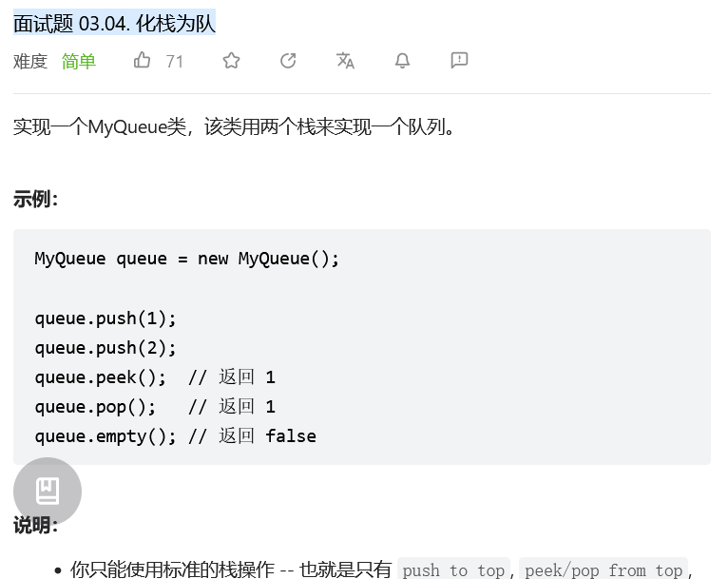
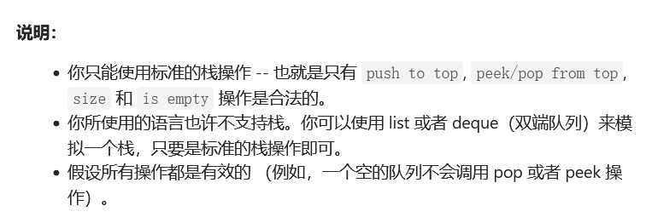
class MyQueue:

def __init__(self):
"""
Initialize your data structure here.
"""
self.stack1 = []
self.stack2 = []

def push(self, x: int) -> None:
"""
Push element x to the back of queue.
"""
self.stack1.append(x)

def pop(self) -> int:
"""
Removes the element from in front of queue and returns that element.
"""
if len(self.stack2) == 0:
while self.stack1:
self.stack2.append(self.stack1.pop())
return self.stack2.pop()

def peek(self) -> int:
"""
Get the front element.
"""
if len(self.stack2) == 0:
while self.stack1:
self.stack2.append(self.stack1.pop())
return self.stack2[-1]

def empty(self) -> bool:
"""
Returns whether the queue is empty.
"""
return len(self.stack2) == 0 and len(self.stack1) == 0

# Your MyQueue object will be instantiated and called as such:
# obj = MyQueue()
# obj.push(x)
# param_2 = obj.pop()
# param_3 = obj.peek()
# param_4 = obj.empty()

